OPTIMIZED APP BASED VEHICLE ROUTING PROTOCAL
CAPSTONE PROJECT REPORT

Submitted by

CHILAMALA NAGENDRA – 99220040253
K. VINAY – 99220041209
V. NAGA CHAITANYA – 99220040769
P. DEEPTHI – 99220041305

in partial fulfillment for the award of the degree
of
BACHELOR OF TECHNOLOGY
IN

COMPUTER SCIENCE AND ENGINEERING



SCHOOL OF COMPUTING
COMPUTER SCIENCE AND ENGINEERING
KALASALINGAM ACADEMY OF RESEARCH
AND EDUCATION
KRISHNANKOIL 626 126

April 2026

DECLARATION

We affirm that the project work titled “OPTIMIZED APP BASED VEHICLE ROUTING PROTOCAL” being submitted in partial fulfillment for the award of the degree of Bachelor of Technology in Computer Science and Engineering is the original work carried out by us. It has not formed part of any other project work submitted for the award of any degree or diploma, either in this or any other University.

CHILAMALA NAGENDRA
99220040253
K.VINAY
99220041209
V.NAGA CHAITANYA
99220040769
P.DEEPTHI
99220041305

This is to certify that the above statement made by the candidate is correct to the best of my knowledge.
Date:

Signature of supervisor
Dr. M .K.NAGARAJAN
Associate/Assistant Professor
Department of Computer Science and Engineering



BONAFIDE CERTIFICATE

Certified that this project report “OPTIMIZED APP BASED VEHICLE ROUTING PROTOCAL
” is the bonafide work of “Chilamala Nagendra(99220040253), K.Vinay(99220040394)
V. Naga chaitanya(99220040769), P.Deepthi (99220041305)” who carried out the project work under my supervision.

Dr.M.K.NAGARAJAN | Dr. R.Raja Subramanian
SUPERVISOR | HEAD OF THE DEPARTMENT
Associate/Assistant Professor | Associate Professor & Head
Computer Science and Engineering | Computer Science and Engineering
Kalasalingam Academy of Research and Education | Kalasalingam Academy of Research and Education
Krishnankoil 626126 | Krishnankoil 626126
Virudhunagar District. | Virudhunagar District.

Submitted for the Project Viva-voce examination held on

Internal Examiner External Examiner

ACKNOWLEDGEMENT

We would like to begin by expressing our heartfelt gratitude to the Supreme Power for the immense grace that enabled us to complete this project.
We are deeply grateful to the late "Kalvivallal" Thiru T. Kalasalingam, Chairman of the Kalasalingam Group of Institutions, and to "Illayavallal" Dr. K. Sridharan, Chancellor, as well as Dr. S. Shasi Anand, Vice President, who has been a guiding light in all our university’s endeavours.
Our sincere thanks go to our Vice Chancellor, Dr. S. Narayanan, for his inspiring leadership, guidance, and for instilling in us the strength and enthusiasm to work towards our goals.
We would like to express our sincere appreciation to Dr. P. Deepa Lakshmi, Professor & Dean-(SoC), Director Accreditation & Ranking, for her valuable guidance. Our heartfelt gratitude also goes to our esteemed Head of Department, Dr. R. Raja Subramanian, whose unwavering support has been crucial to the successful advancement of our project.
We are especially thankful to our Project Supervisor, Dr.M.K.Nagarajan for his patience, motivation, enthusiasm, and vast knowledge, which greatly supported us throughout this work.
Our sincere gratitude also goes to Dr.T.Manikumar and Mr.N.R.Sathiskumar Overall Project Coordinators, for their constant encouragement and support in completing this Capstone Project.
Finally, we would like to thank our parents, faculty, non-teaching staff, and friends for their unwavering moral support throughout this journey.


SCHOOL OF COMPUTING
COMPUTER SCIENCE AND ENGINEERING
PROJECT SUMMARY
Project Title | Optimized app based vehicle routing protocal
Project Team Members (Name with Register No) | Chilamala nagendra(99220040379),  k.Vinay(99220041209), V.Naga chaitanya(99220040769), P.Deepthi(99220041305).
Guide Name/Designation | Dr.M.K.Nagarajan
Program Concentration Area | Artificial Intelligence and Machine Learning
Technical Requirements | Operating System, Python, OpenCV, MediaPipe, Bootstrap.
Engineering standards and realistic constraints in these areas
Area | Codes & Standards / Realistic Constraints | Tick ✓
Economic | The proposed campus navigation system is cost-effective as it utilizes modern technologies like Flutter, Google Maps API, and Firebase. Since it is a mobile application, it eliminates the need for physical maps, signboards, and manual assistance systems. The system runs on smartphones, which are already widely available among users, reducing additional hardware costs. Cloud-based services further minimize maintenance and infrastructure expenses.
Environmental | The system significantly reduces paper usage by replacing printed maps, notices, and manual records with digital alternatives. It also minimizes unnecessary movement across campus by providing optimized routes, thereby reducing energy consumption. This contributes to a greener and more sustainable campus environment.
Social | The application improves accessibility for students, faculty, and visitors by providing real-time navigation and centralized information. It enhances user experience by reducing confusion and saving time. The system supports large campus populations efficiently.
Ethical | The system ensures user data privacy by implementing secure authentication and database management using Firebase. Location tracking features should be used responsibly, ensuring user consent and transparency. The system must avoid misuse of personal data and maintain trust among users.
Health and Safety | By providing accurate navigation, the system reduces unnecessary crowding in certain campus areas. It also helps users reach destinations quickly in emergencies. However, users should maintain a balance in mobile usage to avoid excessive screen exposure.
Manufacturability | This is a software-based solution, so no physical manufacturing is required. The application can be easily deployed across institutions using existing mobile devices and cloud platforms. It is highly scalable and can be updated without major infrastructure changes.
Sustainability | The system is designed for long-term use and can be integrated with other smart campus solutions. Future enhancements such as indoor navigation, offline maps, and AI-based recommendations can further improve its usability. It supports the growth of digital and smart campus ecosystems.

ABSTRACT

Large educational institutions often face navigation challenges due to expanding infrastructure and complex layouts. Traditional methods such as signboards and printed maps are inefficient in providing real-time assistance. This project proposes an Optimized App-Based Routing and Campus Navigation System developed using Flutter, integrated with Google Maps API for real-time routing and Firebase for backend services.The system integrates GPS-based navigation, faculty directory search, events and notices management, lost-and-found tracking, and a structured feedback module into a single mobile application. The routing engine applies graph-based shortest path algorithms such as Dijkstra and A* to compute optimal campus routes.The application improves campus accessibility, reduces time wastage, enhances communication efficiency, and supports digital transformation within educational institutions.
The system is developed using Flutter for cross-platform mobile development and Firebase for backend services, with integration of Google Maps API for real-time location tracking and route guidance. It implements graph-based shortest path algorithms such as Dijkstra and A* to compute optimized routes between campus buildings, ensuring reduced travel time and improved navigation accuracy.
In addition to navigation, the application integrates multiple campus services including faculty directory search, events and notices management, lost-and-found tracking, and a structured feedback system. Real-time cloud synchronization ensures up-to-date information access while maintaining data security and reliability.

The proposed solution improves operational efficiency, enhances user convenience, reduces dependency on manual systems, and supports the digital transformation of educational institutions. The system is scalable, cost-effective, and adaptable for future enhancements such as AI-based assistants and offline navigation support.
Keywords - Campus Navigation, Route Optimization, Flutter, Firebase, Google Maps API, Smart Campus, Mobile Application.

TABLE OF CONTENTS
TITLE |  | PAGE NO.
ABSTRACT |  | 7
LIST OF TABLES |  | 12
LIST OF FIGURES |  | 13
LIST OF ACADEMIC REFERENCE COURSES |  | 14
CHAPTER I | INTRODUCTION | 15
1.1 | Background and Motivation
1.2 | Problem Statement
1.3 | Objectives of the Project
1.4 | Scope of the Project
1.5 | Methodology Overview
1.6 | Organization of the Report
CHAPTER II | LITERATURE REVIEW | 20
2.1 | Overview of Related Work | 20
2.2 | Review of Similar Projects or Research Papers | 21
2.3 | Summary and Gap Identification | 22
CHAPTER III | SYSTEM ANALYSIS | 24
3.1 | Requirements Gathering | 24
3.2 | Functional Requirements | 25
3.3 | Non-Functional Requirements | 26
3.4 | Feasibility Study  - Technical Feasibility  - Operational Feasibility  - Economic Feasibility | 27
3.5 | Risk Analysis | 28
CHAPTER IV | SYSTEM DESIGN | 30
4.1 | Overall System Architecture | 30
4.2 | Module Design | 31
4.2.1 | Module 1 | 31
4.2.2 | Module 2(Repeat as per your requirements) | 32
4.3 | Database Design | 33
4.3.1 | ER Diagram | 34
4.3.2 | Database Schema | 35
4.4 | User Interface Design | 36
4.4.1 | User Flow Diagrams | 36
CHAPTER V | IMPLEMENTATION | 38
5.1 | Technology Stack | 38
5.1.1 | Programming Languages and Tools | 38
5.2 | Implementation of Modules | 39
5.2.1 | Module 1 | 39
5.2.2 | Module 2(Repeat as many time as required) | 40
5.3 | Integration of Modules | 42
CHAPTER VI | TESTING | 44
6.1 | Testing Methodology | 44
6.1.1 | Unit Testing | 44
6.1.2 | Integration Testing | 46
6.1.3 | System Testing | 46
6.1.4 | User Acceptance Testing (UAT) | 47
6.2 | Test Cases and Results | 47
6.3 | Bug Tracking and Resolution | 48
CHAPTER VII | RESULTS AND DISCUSSION | 50
7.1 | System Output Screenshots | 51
7.2 | Evaluation Metrics | 52
7.3 | Comparison with Existing Systems | 53
7.4 | Challenges Faced | 54
7.5 | Solutions and Improvements | 55
CHAPTER VIII | CONCLUSION & FUTURE SCOPE | 56
REFERENCES : List of books, articles, research papers, and other resources used |  | 58
PUBLICATION
CERTIFICATIONS
PLAGIARISM REPORT

LIST OF TABLES

TABLES | DETAILS | PAGE NO.
Table 1 | Libraries and Frameworks | 39
Table 2 | Test Cases and Results | 47
Table 3 | Comparison with Existing Systems | 53

LIST OF FIGURES
FIGURES | DETAILS | PAGE NO.
Figure 1 | Normal Forward Detection | 50
Figure 2 | Looking left Direction | 50
Figure 3 | Looking Right Direction | 50
Figure 4 | Looking Down Detection | 51
Figure 5 | Multi-Face Detection | 51
Figure 6 | Cheat Probability Graph | 52

LIST OF ACADEMIC REFERENCE COURSES
S. NO. | COURSE CODE | COURSE NAME
1 | 212CSE2301 | Data Structures
2 | 212CSE2305 | Database Management Systems
3 | 213CSE1301 | Artificial Intelligence
4 | 213CSE1301 | Machine Learning
5 | 211CSE1402 | Python Programming

CHAPTER – I
INTRODUCTION

1.1 Background and Motivation
Large educational institutions today function as self-contained ecosystems that include academic blocks, administrative offices, hostels, laboratories, libraries, and various service facilities spread across vast campus areas. As campuses continue to expand in size and complexity, students, faculty, and visitors often face difficulties in navigating through these environments efficiently. Locating classrooms, departments, offices, or amenities can become time-consuming and confusing, particularly for newcomers or visitors unfamiliar with the campus layout.
Traditional navigation methods such as static maps, signboards, or verbal directions are often insufficient, as they lack real-time updates and interactive guidance. These limitations can lead to delays, inconvenience, and reduced productivity. With the rapid advancement of mobile technology, location-based services, and smart applications, there is an opportunity to develop intelligent solutions that simplify campus navigation and improve user experience.
The Campus Companion project is motivated by the need to provide a smart, user-friendly, and real-time navigation system that assists users in easily locating destinations within a campus. By leveraging digital mapping, mobile interfaces, and interactive features, the system aims to enhance accessibility, reduce confusion, and improve overall campus mobility.
1.2 Problem Statement
Navigating large and complex campus environments is a common challenge faced by students, faculty members, and visitors. Existing solutions such as printed maps or directional signboards are often static and do not provide personalized or real-time guidance. As a result, users may struggle to find the shortest path, locate specific facilities, or identify nearby resources efficiently.Additionally, new students and visitors are particularly affected due to their lack of familiarity with campus infrastructure. This can lead to wasted time, missed schedules, and frustration. Another issue is the absence of a centralized system that provides comprehensive information about campus locations, routes, and services in a single platform.
Therefore, there is a need for a smart and interactive system that can provide real-time navigation assistance, accurate location details, and user-friendly guidance within a campus. The Campus Companion project aims to address these challenges by developing a digital platform that simplifies navigation and enhances accessibility for all users.

1.3 Objectives of the Project
The primary objective of the Campus Companion project is to design and develop a smart navigation system that assists users in efficiently locating places within a campus environment The system aims to provide an interactive digital map that displays various campus locations such as academic buildings, offices, hostels, and facilities. It also focuses on implementing route optimization to guide users through the shortest or most convenient path to their destination.
Another important objective is to develop a user-friendly interface that allows users to search for locations easily and receive clear navigation instructions. The system also aims to provide real-time updates and location-based services to enhance usability Additionally, the project seeks to improve overall campus accessibility, reduce time spent in navigation, and create a seamless experience for students, faculty, and visitors.
1.4 Scope of the Project
The scope of the Campus Companion system includes the development of a digital platform that provides navigation and location-based services within a campus environment. The system can be used by students, faculty members, administrative staff, and visitors to locate buildings, classrooms, offices, and other facilities.
From a technical perspective, the system focuses on features such as digital mapping, search functionality, route guidance, and user interaction. It may also include additional features such as displaying nearby facilities, providing directions between locations, and offering basic campus information The system has certain limitations. Its performance depends on accurate mapping data and proper implementation of navigation algorithms. It may also require internet connectivity for real-time updates and functionality. Advanced features such as indoor navigation or integration with real-time crowd data may not be included in the current implementation.
1.5 Methodology Overview
The development of the Campus Companion system follows a structured methodology to ensure effective design and implementation. The process begins with requirement analysis, where user needs and challenges related to campus navigation are identified. This is followed by a study of existing navigation systems and technologies to understand their strengths and limitations.
In the system design phase, the overall architecture is planned, including modules such as map interface, location search, route calculation, and user interaction components. During the implementation phase, the system is developed using appropriate programming tools and technologies, integrating mapping services and navigation algorithms.
1.5 Methodology Overview
The development of the WELCOMETOKARE Your Campus Companion application follows a structured methodology to ensure systematic design, development, and implementation of the system. The methodology focuses on identifying user requirements, designing the system
- Requirement Analysis: Identification of system requirements such as campus navigation, faculty directory access, lost and found management, event notifications, and feedback submission features.
- Literature Review: Study of existing campus navigation systems and mobile applications to understand current solutions and identify improvements that can enhance campus accessibility and information management.
- System Design: Designing the overall architecture of the application, including user interface design, database structure, and module interactions.
- Module Development: Implementation of different functional modules of the application, including:
- Campus navigation and routing module
- Faculty directory module
- Lost and found management module
- Feedback and complaint module
- Events and notifications module
- Integration: Combining all individual modules into a single unified mobile application to ensure smooth communication between different components.
- Testing: Performing unit testing, integration testing, and system testing to verify functionality, performance, and reliability of the application.
- Evaluation: Evaluating the system performance based on usability, response time, and accuracy of navigation and information retrieval.
1.6 Organization of the Report
The remainder of this report is structured as follows:
- Chapter II – Literature Review: Discusses related works and existing proctoring systems.
- Chapter III – System Analysis: Describes requirements, feasibility study, and risk analysis.
- Chapter IV – System Design: Explains architecture, module design, and database structure.
- Chapter V – Implementation: Details technologies used and module integration.
- Chapter VI – Testing: Presents testing methodology and results.
- Chapter VII – Results and Discussion: Analyzes system performance and output.
- Chapter VIII – Conclusion and Future Scope: Summarizes findings and outlines future enhancements.

CHAPTER II
LITERATURE REVIEW
LITERATURE SURVEY
S.No | Author | Proposed Solution | Advantages | Disadvantages
1 | M. Sangeetha et al. | Developed a Google Maps–assisted campus navigation system with building markers. | Helps users identify block locations easily and supports GPS mapping. | Does not support optimized routing or multi-service integration.
2 | A. Prakash et al | Proposed hybrid GPS and QR-based indoor/outdoor navigation. | Improves indoor accuracy where GPS signal is weak. | Requires manual QR scanning, reducing usability.
3 | Fathima et al. | Created a Flutter-based smart locator system with Firebase backend. | Cross-platform compatibility and real-time data storage. | Lacks shortest path generation and dynamic routing capabilities.
4 | C. Lakshmi et al. | Implemented indoor navigation using BLE beacons. | Accurate micro-location tracking in enclosed spaces. | Expensive deployment and frequent calibration required.
5 | V. Ramakrishnan et al. | Designed GIS-based map visualization for universities. | Supports precise spatial representation of campus layouts. | Not available as a dynamic or mobile-based system.
6 | R. Bakshi et al. | Implemented shortest path algorithms (Dijkstra/A*) for campus layout | Ensures precise and optimized route computation | Not integrated with live map frameworks or mobile

2.1 Overview of Related Work
The rapid development of mobile technologies and smart applications has significantly improved the way people access information and navigate complex environments. Educational institutions today operate as large ecosystems consisting of multiple academic blocks, laboratories, libraries, hostels, and administrative offices. As campus infrastructures expand, the need for efficient digital solutions that assist users in navigating and accessing campus information has become increasingly important.
Traditional campus navigation methods often rely on printed maps, signboards, or manual guidance from security personnel and other students. While these methods provide basic directions, they are often inefficient, difficult to update, and unable to provide real-time information. Additionally, printed maps cannot provide interactive guidance or integrate additional services such as faculty information, event notifications, or feedback systems.
With the widespread adoption of smartphones, mobile applications have emerged as powerful tools for providing navigation and information services. Technologies such as GPS-based navigation, map integration, and mobile databases enable users to locate destinations quickly and access related information in real time. Many universities have started developing campus navigation applications to improve student convenience and administrative communication.
Recent advancements in cross-platform development frameworks such as Flutter have further simplified mobile application development. Flutter allows developers to build applications for both Android and iOS platforms using a single codebase. Combined with modern programming languages such as Dart, these technologies enable the creation of scalable, responsive, and user-friendly applications.
Modern campus management applications integrate multiple features such as navigation assistance, faculty directories, event management systems, lost and found services, and feedback platforms. These systems aim to centralize campus services and improve communication between students, faculty, and administrators. However, many existing solutions still lack integration of multiple campus services into a single user-friendly platform.
This review highlights the evolution of campus navigation and information management systems and establishes the need for a comprehensive mobile application that integrates navigation, communication, and campus information services in a unified environment.

2.2 Review of Similar Projects or Research Papers
Several researchers and developers have proposed mobile-based campus navigation systems to improve accessibility and information sharing within educational institutions. These systems attempt to simplify campus navigation and provide centralized access to institutional resources.
Various studies have explored the use of mobile applications to guide students through large campuses using map-based navigation. Some systems integrate GPS-based navigation to identify building locations and provide route guidance between different campus facilities. While such applications provide basic navigation support, their accuracy may be affected by GPS limitations, especially in densely constructed areas or indoor environments.
Some research projects have focused on integrating faculty directories within campus applications. These systems allow students to search for faculty members, access their office locations, and view contact details. Such features help improve communication between students and faculty members. However, many of these systems operate as standalone solutions and do not integrate additional services such as event notifications or feedback systems.
Other researchers have introduced campus information systems that include event management modules. These systems enable institutions to publish announcements about seminars, workshops, and academic activities. While these platforms help students stay informed about upcoming events, they often lack navigation support or personalized information access.
Lost and found management systems have also been implemented in certain campus applications to assist users in reporting and retrieving misplaced items. These systems typically allow users to upload item descriptions and images. However, in many cases these features are implemented as separate web portals rather than being integrated into a comprehensive campus companion application.
Recent mobile applications have attempted to combine multiple campus services into a single platform using cross-platform frameworks such as Flutter. These applications aim to provide better user experiences through responsive interfaces and real-time data access. Despite these improvements, many existing systems still lack seamless integration of navigation, faculty directories, lost and found services, feedback mechanisms, and event management features within a single unified application.
2.3 Summary and Gap Identification
The literature review on campus navigation and information management systems reveals significant progress in developing mobile-based solutions for educational institutions. However, several limitations and research gaps still exist.
One major limitation is the lack of integration among different campus services. Many existing applications focus only on a single feature such as navigation or event announcements, rather than providing a unified platform that combines multiple services.
Another challenge is the limited accessibility of faculty information and office locations within many systems. Students often struggle to find accurate information about faculty members and their cabin locations due to outdated or fragmented data sources.
Additionally, traditional lost and found management processes remain largely manual in many institutions. Without a centralized digital system, recovering lost items becomes difficult and time-consuming.
Communication between students and campus administration is another area that requires improvement. Many institutions lack a structured digital platform where students can easily submit feedback, complaints, or suggestions.
The proposed Campus Companion application addresses these gaps by integrating multiple campus services into a single mobile platform. The system combines navigation assistance, faculty directory access, lost and found management, feedback submission, and event notifications within one applicatio

CHAPTER III
SYSTEM ANALYSIS
3.1 Requirements Gathering
Requirement gathering is a crucial phase in the development of the Campus Companion application, as it helps identify the functional and non-functional expectations required to build an efficient and user-friendly campus assistance platform. The requirements were identified through a structured analysis process that involved studying the difficulties faced by students and visitors while navigating large campus environments, reviewing existing campus navigation applications, collecting feedback from students and faculty members, and analyzing institutional requirements for improving communication and accessibility within the campus.
Large educational institutions often consist of multiple academic blocks, laboratories, administrative offices, hostels, libraries, and recreational facilities spread across a wide geographical area. New students and visitors frequently experience difficulty locating buildings, faculty offices, and event venues. Traditional navigation methods such as printed maps, signboards, or verbal guidance are often insufficient and cannot provide interactive or real-time assistance. Therefore, the proposed system aims to provide a centralized mobile application that simplifies campus navigation and integrates several useful campus services.
The identified requirements were categorized into hardware, software, and operational components to ensure organized system development and efficient implementation. From a hardware perspective, the system requires a smartphone device with basic capabilities such as GPS support, camera access, and internet connectivity. Since the application is mobile-based, it is designed to operate on commonly available smartphones used by students and faculty. A device with at least 4 GB RAM and moderate processing capability is sufficient to ensure smooth application performance and responsive user interaction.
From a software perspective, the application is developed using the Flutter framework, which enables cross-platform development for both Android and iOS devices using a single codebase. The programming language used is Dart, which supports efficient UI development and application logic. The system also utilizes Firebase or similar cloud-based backend services to store and manage data such as faculty details, events, feedback submissions, and lost-and-found records. Integration with map services helps provide accurate location-based navigation within the campus environment.
Operationally, the system must function efficiently in real-time while providing reliable access to campus services. The application should allow users to easily search for locations, view faculty information, access event notifications, report lost items, and submit feedback to campus administrators. The system must also ensure smooth communication between users and the administrative backend while maintaining data security and accessibility.
By clearly defining these requirements, the development process ensures that the WELCOMETOKARE application delivers a reliable, scalable, and user-friendly digital solution that enhances campus navigation and improves communication within the institutional environment.

3.2 Functional Requirements
Functional requirements describe the core operations and capabilities that the WELCOMETOKARE – Campus Companion system must perform to assist users in navigating and accessing campus services effectively. The primary function of the system is to provide an interactive campus navigation system that enables students, faculty members, and visitors to locate different buildings and facilities within the campus easily. The application must allow users to search for specific locations such as classrooms, laboratories, faculty cabins, administrative offices, libraries, and hostels, and provide navigation guidance to reach those destinations.
Another important functionality of the system is the faculty directory module, which allows users to search for faculty members and view their details, including department, designation, office location, and contact information. This feature improves communication between students and faculty and helps users quickly identify the location of faculty offices within the campus.The application must also include an event management module that allows the institution to publish information about upcoming campus events such as workshops, seminars, cultural programs, and academic activities. Users should be able to view event details including date, time, venue, and event descriptions directly through the application.
A lost and found management feature is another important component of the system. This module allows users to report lost items or upload information about found items within the campus. The system should allow users to submit item descriptions and images so that lost belongings can be identified and returned to their rightful owners more efficiently.The system must also implement a feedback and complaint submission module that enables students to share suggestions, report issues, or provide feedback to campus administration. This feature helps improve communication between users and institutional authorities and allows administrators to address campus-related concerns more effectively.
Additionally, the system should provide a user-friendly interface that allows users to access all services easily through a well-organized navigation structure. The application should load quickly, provide smooth transitions between screens, and ensure reliable performance across different devices These functional requirements collectively ensure that the system provides a comprehensive digital platform that enhances campus navigation, improves access to information, and supports better interaction between students, faculty, and administration.
3.3 Non-Functional Requirements
Non-functional requirements describe the performance standards, quality attributes, and operational constraints that ensure the WELCOMETOKARE application functions efficiently and reliably in real-world environments. One of the most important aspects is performance, where the application must load quickly and respond to user inputs without delays. Efficient memory and resource management are necessary to ensure smooth performance even on smartphones with moderate hardware specifications.
Another important requirement is usability, as the application must provide a simple and intuitive interface that can be easily used by students, faculty members, and visitors without requiring technical expertise. The application design should follow modern mobile interface guidelines and ensure that users can access different modules quickly and conveniently.
Reliability is another essential attribute, ensuring that the system operates consistently without crashes or unexpected errors. The application should maintain stable performance even when multiple users access the system simultaneously. Data stored within the system must remain accurate and accessible at all times Scalability is also an important factor because the application may need to support increasing numbers of users as the institution grows. The backend architecture should allow future expansion, enabling the addition of new features or integration with other campus services without major redesign.
Security and privacy requirements ensure that user data and submitted information such as feedback reports or lost item details are stored securely. Access control mechanisms must prevent unauthorized access to administrative data, and sensitive information should be protected through secure data handling practices Finally, compatibility is an important non-functional requirement, ensuring that the application works across multiple mobile devices and operating system versions. The use of cross-platform development technologies allows the system to operate on both Android and iOS platforms while maintaining consistent functionality and user experience.
3.4 Feasibility Study
Feasibility analysis evaluates whether the proposed system is practical, implementable, and beneficial for the institution.
3.4.1 Technical Feasibility
The proposed system is technically feasible because modern mobile development technologies make it possible to create scalable and efficient applications. The use of the Flutter framework allows developers to build cross-platform mobile applications using a single codebase, reducing development complexity and improving maintainability.
Cloud-based backend services such as Firebase enable efficient data storage, real-time updates, and secure data management. Integration with map services provides accurate location-based navigation, allowing users to easily identify campus buildings and facilities.
Additionally, the hardware requirements for running the application are minimal, as most modern smartphones already support GPS, internet connectivity, and sufficient processing power. Therefore, the system can be implemented without requiring specialized equipment or infrastructure.

3.4.2 Operational Feasibility
The system is operationally feasible because it directly addresses the challenges faced by students, visitors, and faculty members in navigating large campus environments. Most students already use smartphones daily, making it easy to adopt a mobile-based campus companion application.
The application simplifies access to campus information and reduces the need for manual guidance or printed maps. Administrative staff can easily update faculty details, event information, and announcements through the system.
By providing a centralized platform for campus services, the application improves communication and information sharing within the institution, making its operational adoption practical and beneficial.
3.4.3 Economic Feasibility
The proposed system is economically feasible because it uses widely available open-source technologies and existing infrastructure. Development tools such as Flutter and Dart are freely available, eliminating licensing costs.
Since the application runs on users’ personal smartphones, there is no need for institutions to invest in additional hardware. The backend infrastructure can be hosted using cost-effective cloud services, making deployment affordable even for smaller institutions.
Additionally, the system reduces operational costs by minimizing the need for printed campus maps and manual assistance for navigation and information sharing. Therefore, the overall cost of implementation remains low while providing significant benefits to the institution.
3.5 Risk Analysis
Risk analysis helps identify potential challenges that may affect the successful implementation and operation of the WELCOMETOKARE – Your Campus Companion application.
One potential technical risk is the accuracy of navigation services, which may depend on GPS signals and internet connectivity. In certain situations, such as indoor locations or areas with weak signals, location accuracy may be reduced. Another technical challenge may arise from compatibility issues across different smartphone models and operating system versions, which could affect application performance.
Operational risks may include outdated or incorrect campus information if administrators fail to update faculty details, event announcements, or location data regularly. Inaccurate information could reduce user trust in the application.
There are also security and privacy concerns related to storing user-submitted data such as feedback messages or lost-and-found item reports. Unauthorized access or misuse of stored data could compromise user privacy.
To mitigate these risks, several preventive measures must be implemented. The system should allow administrators to update campus information regularly to maintain accuracy. Secure authentication and access control mechanisms must be used to protect sensitive data. Regular testing across multiple devices and operating systems should be conducted to ensure compatibility and stable performance.

CHAPTER IV
SYSTEM DESIGN
4.1 Overall System Architecture
The WELCOMETOKARE – Campus Companion application is designed using a modular and scalable architecture that integrates mobile user interaction, backend data management, and cloud-based services to provide an efficient campus navigation and information management platform. The system architecture is structured into four primary layers: the Input Layer, Application Processing Layer, Data Management Layer, and Presentation Layer each responsible for specific tasks that ensure smooth system operation, scalability and maintainability.
The Input Layer represents the interaction point between the user and the system. In this layer, users interact with the mobile application through various input methods such as touchscreen navigation, search queries, form submissions, and location-based services. Users can search for campus locations, view faculty details, report lost items, browse upcoming events, and submit feedback to campus administration. The smartphone’s built-in GPS and internet connectivity are utilized to provide location-based navigation and access to real-time information.
The collected user inputs are then transmitted to the Application Processing Layer, where the core application logic is implemented. This layer processes user requests, performs data validation, manages navigation functionality, and handles interactions between different modules of the system. For example, when a user searches for a building or faculty office, the system retrieves the relevant information from the database and calculates navigation paths if required. Similarly, when a user submits feedback or reports a lost item, the system processes the request and stores it securely in the backend database.
The Data Management Layer is responsible for storing and managing all application data. This layer uses cloud-based database services such as Firebase or other database management systems to store information related to faculty directories, campus locations, event announcements, lost and found records, and user feedback. The database ensures structured storage of information while maintaining data consistency, security, and accessibility.
Finally, the Presentation Layer provides the user interface through which users interact with the system. This layer is implemented using the Flutter framework, which allows the development of responsive and visually appealing mobile interfaces. The interface displays navigation maps, faculty information pages, event notifications, and other system features in a clear and organized manner. The presentation layer ensures smooth user interaction and enhances the overall usability of the application.
The entire system operates through continuous communication between these layers, ensuring efficient data flow and seamless functionality. This layered architecture improves maintainability, enables future expansion, and supports the integration of additional campus services as needed.

4.2 Module Design
To improve system maintainability, scalability, and development efficiency, the WELCOMETOKARE application is divided into several independent but interconnected modules. Each module performs a specific function within the system while communicating with other modules to provide a complete campus companion solution.
4.2.1 Module 1 – Campus Navigation Module
The Campus Navigation Module is one of the core components of the WELCOMETOKARE system, designed to assist users in locating various facilities within the campus environment. Large educational institutions often consist of multiple buildings and departments spread across wide areas, making navigation difficult for new students and visitors. This module provides an interactive navigation system that helps users easily locate different buildings, classrooms, laboratories, hostels, libraries, and administrative offices.
The module operates by integrating map-based navigation services within the mobile application. Users can search for a specific location within the campus, and the system retrieves the corresponding location information from the database. The application then displays the selected destination on the map and provides route guidance to help users reach their destination efficiently.The navigation module also allows users to view important details about each location, such as the building name, department, and nearby facilities. This feature ensures that users not only reach the correct location but also gain useful contextual information about the campus infrastructure.
4.2.2 Module 2 – Faculty Directory Module
The Faculty Directory Module is designed to provide students and visitors with easy access to faculty-related information. In large institutions, students often find it difficult to locate faculty offices or obtain accurate contact details. This module addresses that issue by maintaining a structured database containing faculty information.
Users can search for faculty members using various parameters such as faculty name, department, or designation. Once a faculty member is selected, the application displays relevant information including department name, designation, office location, and contact details. In addition, the system may also provide navigation assistance to help users locate the faculty office within the campus.This module improves communication between students and faculty members by making essential information easily accessible through a centralized digital platform.
4.2.3 Module 3 – Event Management Module
The Event Management Module is responsible for providing information about upcoming campus activities such as seminars, workshops, cultural programs, and academic conferences. Educational institutions frequently organize events that students may miss due to lack of timely information.
Through this module, administrators can upload event details including event name, description, date, time, and venue. These details are stored in the database and displayed within the mobile application for users to view.
Students can browse the list of upcoming events and access detailed information about each event. This feature encourages greater student participation in academic and extracurricular activities while improving communication between the institution and its students.
4.2.4 Module 4 – Lost and Found Management Module
The Lost and Found Management Module helps manage lost or misplaced items within the campus environment. Losing personal belongings such as ID cards, mobile phones, or notebooks is a common issue in large campuses.This module allows users to report lost items by submitting item descriptions, images, and contact information through the application. Similarly, users who find misplaced items can upload information about the discovered item so that it can be returned to its rightful owner.
All submitted reports are stored in the system database and can be viewed by other users through the application. This digital approach improves the efficiency of the lost-and-found process and increases the chances of recovering lost belongings.
4.2.5 Module 5 – Feedback and Complaint Module
The Feedback and Complaint Module allows users to communicate directly with campus administration by submitting feedback, suggestions, or complaints regarding campus facilities or services. This feature helps institutions identify issues and improve campus infrastructure and services.
Users can submit feedback through a simple form within the mobile application. The submitted information is securely stored in the system database and can be accessed by authorized administrators for review.This module promotes transparency and encourages active participation from students in improving campus services.
4.3 Database Design
The database design of the WELCOMETOKARE system ensures efficient storage and retrieval of campus-related information. A structured database is required to manage data related to faculty members, campus locations, events, lost and found reports, and user feedback.

4.3.1 ER Diagram (Conceptual Explanation)
The conceptual database design consists of several core entities including User, Faculty, Location, Event, Lost Item and Feedback.
The User entity stores information about application users, including User_ID as the primary key, along with Name, Email, and Role details. The Faculty entity maintains faculty information such as Faculty_ID, Name, Department, Designation, and Office_Location.
The Location entity stores information about campus buildings and facilities, including Location_ID, Building_Name, Department, and Map_Coordinates. The Event entity records details about campus events, including Event_ID, Event_Name, Date, Time, and Venue.
The Lost_Item entity manages reports related to lost or found items, including Item_ID, Description, Image, Status, and Contact_Details. Finally, the Feedback entity stores feedback or complaints submitted by users, including Feedback_ID, User_ID, Message, and Timestamp.
These entities are connected through relationships that maintain data integrity and allow efficient retrieval of information. For example, one user can submit multiple feedback entries, and one location can be associated with multiple faculty offices.
4.3.2 Database Schema (Sample SQL)
CREATE TABLE User (
User_ID INT PRIMARY KEY,
Name VARCHAR(100),
Email VARCHAR(100),
Role VARCHAR(50)
);
CREATE TABLE Faculty (
Faculty_ID INT PRIMARY KEY,
Name VARCHAR(100),
Department VARCHAR(100),
Designation VARCHAR(100),
Office_Location VARCHAR(100)
);
CREATE TABLE Location (
Location_ID INT PRIMARY KEY,
Building_Name VARCHAR(100),
Department VARCHAR(100),
Map_Coordinates VARCHAR(100)
);
CREATE TABLE Event (
Event_ID INT PRIMARY KEY,
Event_Name VARCHAR(100),
Date DATE,
Time VARCHAR(50),
Venue VARCHAR(100)
);
CREATE TABLE Lost_Item (
Item_ID INT PRIMARY KEY,
Description TEXT,
Image_URL VARCHAR(255),
Status VARCHAR(50),
Contact_Details VARCHAR(100)
);
CREATE TABLE Feedback (
Feedback_ID INT PRIMARY KEY,
User_ID INT,
Message TEXT,
Timestamp DATETIME,
FOREIGN KEY (User_ID) REFERENCES User(User_ID)
);

4.4 User Interface Design
The WELCOMETOKARE application provides a simple, intuitive, and responsive interface designed to enhance the user experience for students, faculty members, and campus visitors.
Design Principles
- Simple and intuitive navigation
- Clean and minimalistic layout
- Fast response and smooth transitions
- Easy access to campus services
- Consistent interface across all screens
4.4.1 User Flow Diagrams (Textual Representation)
The operation of the WELCOMETOKARE system can be described through three major workflows: the User Flow, Administrator Flow, and System Flow.
In the User Flow, the process begins when the user opens the mobile application and logs into the system. After login, the user accesses the main dashboard where different services such as campus navigation, faculty directory, events, lost and found, and feedback options are available. The user selects a desired feature, performs actions such as searching for locations or viewing faculty details, and receives the required information directly within the application.In the Administrator Flow, the administrator logs into the backend system and manages campus data such as faculty information, event announcements, and lost item records. The administrator can update, add, or remove information from the database to ensure that the application provides accurate and up-to-date information to users.
The System Flow represents the internal functioning of the application. When a user submits a request, the system processes the input through the application logic layer, retrieves relevant data from the database, and displays the results through the user interface. The system also stores feedback submissions, lost item reports, and other user-generated content securely in the backend database.

CHAPTER V
IMPLEMENTATION
5.1 Technology Stack
The WELCOMETOKARE – Your Campus Companion application is implemented using modern mobile development technologies that support cross-platform compatibility, real-time data access, and scalable backend services. The selected technology stack focuses on ease of development, high performance, maintainability, and cost-effectiveness.
The application is primarily developed using the Flutter framework, which enables developers to create applications for both Android and iOS platforms using a single codebase. Flutter provides a rich set of user interface components and supports responsive design, allowing the application to maintain consistent performance across different devices.
The backend services are supported using cloud-based platforms such as Firebase, which provide database storage, authentication services, and real-time data synchronization. This enables the application to manage dynamic data such as faculty details, event announcements, lost-and-found records, and user feedback efficiently.
Core Technologies
• Flutter – Cross-platform mobile application development
• Dart – Programming language used for application logic
• Firebase – Cloud-based backend services and real-time database
• Google Maps API – Location-based navigation and map visualization
• REST APIs – Data communication between frontend and backend
• Material UI Components – User interface design elements
5.1.1 Programming Languages and Tools
Programming Language
Dart Programming Language
The Dart language is used as the primary programming language for developing the WELCOMETOKARE application. Dart integrates seamlessly with the Flutter framework and provides strong support for building responsive and high-performance mobile applications.
- Efficient support for Flutter-based UI development
- Fast compilation and high application performance
- Strong object-oriented programming capabilities
- Easy integration with backend APIs and cloud services
- Support for asynchronous programming for handling network requests
Development Tools
The development and testing of the application are carried out using several modern development tools that simplify coding, debugging, and version management.
• Visual Studio Code (VS Code) – Primary code editor used for Flutter development
• Android Studio – Emulator and device testing environment
• Flutter SDK – Development toolkit for building mobile applications
• Firebase Console – Backend configuration and database management
• Git – Version control system for source code management
Libraries and Frameworks
Tool / Library | Purpose
Flutter Framework | Mobile application development
Dart | Application programming language
Firebase Firestore | Cloud database storage
Firebase Authentication | User login and authentication
Google Maps API | Location and navigation services
HTTP Package | API communication
Material UI | User interface components

5.2 Implementation of Modules
The WELCOMETOKARE system is implemented using a modular architecture to simplify development, testing, and maintenance. Each module is designed to perform a specific function while interacting with other modules to provide a complete campus companion platform.
5.2.1 Module 1 – Campus Navigation Module
The Campus Navigation Module is implemented to assist users in locating buildings and facilities within the campus environment. The module integrates map-based services within the mobile application using the Google Maps API The implementation begins with retrieving location data from the backend database. Each campus building is stored with coordinates, building name, and department details. When a user searches for a location within the application, the system processes the search request and retrieves the corresponding location data.
The retrieved coordinates are then displayed on the interactive map interface. Users can view the destination location and follow the suggested path to reach their destination. The system also allows users to zoom in or out on the map and explore nearby campus facilities.
5.2.2 Module 2 – Faculty Directory Module
The Faculty Directory Module is implemented to provide easy access to faculty information within the campus. The module retrieves faculty data from the backend database and displays it within the mobile application.
The implementation begins with creating a structured database containing faculty details such as faculty name, department, designation, and office location. When a user searches for a faculty member, the system queries the database and retrieves the relevant records The retrieved information is displayed in a structured format within the application interface. Users can view detailed information about the selected faculty member, including their office location and department. In some cases, navigation assistance may also be provided to help users locate the faculty office.
5.2.3 Module 3 – Event Management Module
The Event Management Module is implemented to provide real-time information about campus events and activities. Educational institutions regularly conduct seminars, workshops, and cultural programs, and this module helps ensure that students stay informed about these activities Administrators can add new events through the backend system by entering details such as event name, description, date, time, and venue. These details are stored in the cloud database.
The mobile application retrieves this information and displays it in the events section. Users can browse through the list of upcoming events and view detailed information about each event.
5.2.4 Module 4 – Lost and Found Management Module
The Lost and Found Management Module helps users report and track lost or found items within the campus. The implementation begins by creating a form within the mobile application where users can submit details about lost items Users can enter information such as item description, location where the item was lost or found, and contact details. The system may also allow users to upload images of the item to improve identification.
Once submitted, the information is stored in the database and displayed in the lost and found section of the application. Other users can view these reports and contact the person who submitted the report if they find the item.
5.2.5 Module 5 – Feedback and Complaint Module
The Feedback and Complaint Module is implemented to allow users to communicate directly with campus administration. The module provides a simple form where users can submit feedback, suggestions, or complaints regarding campus facilities and services.
When a user submits feedback, the information is transmitted to the backend server and stored in the database along with a timestamp and user details. Administrators can access these records through the administrative dashboard and review the submitted feedback.
5.3 Integration of Modules
The integration phase combines all the individual modules of the WELCOMETOKARE system into a single unified mobile application. This stage ensures smooth communication between the user interface, backend services, and database systems.
The application follows a structured data flow process. When a user interacts with the mobile interface, the request is processed by the application logic layer. The system then communicates with the backend database to retrieve or store the required information.
For example, when a user searches for a building, the navigation module retrieves the location data from the database and displays it on the map interface. Similarly, when a user submits feedback or reports a lost item, the information is stored securely in the backend database.
Firebase services enable real-time synchronization of data between the application and the database. This ensures that updates made by administrators, such as new event announcements or updated faculty details, are immediately reflected within the application

CHAPTER VI
TESTING
6.1 Testing Methodology
Testing is a crucial phase in the development of the Campus Companion system to ensure that the application functions correctly, efficiently, and reliably in real-world campus environments. The system was tested under various scenarios to validate its navigation accuracy, usability, and performance.
The testing process followed a structured approach:
- Unit Testing
- Integration Testing
- System Testing
- User Acceptance Testing (UAT)

6.1 Testing Methodology
Testing plays a vital role in ensuring that the Campus Companion system operates efficiently, accurately, and reliably in real-world campus environments. The objective of testing is not only to identify errors but also to validate whether the system meets user expectations in terms of navigation accuracy, usability, and responsiveness. The testing process was carried out in a structured and systematic manner, covering multiple levels including unit testing, integration testing, system testing, and user acceptance testing. Each stage focused on different aspects of the system, starting from validating individual modules to evaluating the complete system under practical conditions. This layered approach ensured that both standalone components and the fully integrated system performed as intended without errors or inconsistencies.
6.1.1 Unit Testing
Unit testing was conducted to verify the functionality of each individual module within the Campus Companion system before integrating them into a unified platform. The location detection module was tested to ensure accurate retrieval of the user’s current position, either through GPS-based tracking or manual input. The module successfully identified user coordinates and converted them into meaningful location data, although slight delays were observed during initial GPS signal acquisition in low connectivity areas.
The navigation module was tested independently to evaluate its ability to compute the shortest path between different campus locations. Various source and destination combinations were provided as input, and the system consistently generated optimal routes based on distance and accessibility. The search functionality was also examined to ensure that users could easily locate campus facilities such as academic blocks, libraries, hostels, and cafeterias. The results showed that the system returned accurate and relevant search outputs based on user queries Additionally, the map visualization module was tested to verify the correct display of routes, markers, and user location. The interface successfully rendered paths and updated visual elements in real time. Overall, unit testing confirmed that each module functioned correctly in isolation, with only minor performance variations under specific environmental conditions.
6.1.2 Integration Testing
Integration testing was performed to evaluate how well the individual modules of the Campus Companion system interacted with each other when combined into a single application. This phase focused on ensuring smooth data flow and communication between modules, particularly between the location detection, navigation, search, and map visualization components. The system was tested by combining real-time location inputs with navigation algorithms to generate dynamic routes, ensuring that the user’s movement was accurately reflected on the map.
The interaction between the search module and the map module was also verified to confirm that selected locations were correctly displayed along with navigation paths. Furthermore, real-time updates were tested to ensure that any changes in the user’s position were immediately reflected in route recalculations. The results demonstrated that the modules were well-integrated, with no significant synchronization issues or data inconsistencies. The system maintained stable performance even during continuous usage, confirming the effectiveness of the integration process.

6.1.3 System Testing
System testing was conducted to evaluate the overall performance of the Campus Companion system under realistic conditions that simulate actual campus usage. This phase involved testing the complete application as a whole, including all integrated modules, to ensure that it met functional and performance requirements. Various real-world scenarios were considered, such as navigating between different academic buildings, searching for campus facilities, handling invalid or unknown inputs, and tracking user movement in real time The system demonstrated high accuracy in route mapping and location detection, particularly in well-connected areas with stable GPS signals. The response time for generating navigation paths was minimal, ensuring a smooth user experience without noticeable delays. The application also maintained stability during extended usage, operating continuously without crashes or performance degradation. The user interface was found to be responsive and intuitive, allowing users to interact with the system easily
6.1.4 User Acceptance Testing (UAT)
User Acceptance Testing was carried out with a group of students and campus visitors to evaluate the system from an end-user perspective. This phase aimed to determine whether the application meets practical usability requirements and provides a satisfactory user experience. Participants were asked to perform common tasks such as searching for locations, navigating between buildings, and interacting with the map interface.
The feedback collected during this phase was largely positive. Users found the interface to be simple, intuitive, and easy to navigate, even for first-time users. The navigation feature was particularly appreciated, as it provided clear and accurate directions, making it easier for users to move around unfamiliar areas of the campus. Real-time location tracking was also highlighted as a useful feature that enhanced the overall experience.

6.2 Test Cases and Results
Test Case ID | Scenario | Input Condition | Expected Output | Result
TC01 | Normal Navigation | Valid source & destination | Correct route displayed | Pass
TC02 | Invalid Location | Unknown place entered | Error message | Pass
TC03 | Real-time Movement | User changes position | Route updates dynamically | Pass
TC04 | Facility Search | Search "Library" | Correct location shown | Pass
TC05 | Map Display | Load campus map | Proper visualization | Pass
TC06 | Shortest Path | Multiple routes available | Optimal path selected | Pass
TC07 | No GPS Signal | Location unavailable | Prompt for manual input | Pass
6.3 Bug Tracking and Resolution
During the development and testing phases of the Campus Companion system, several issues were identified through systematic testing and performance evaluation. These issues were carefully analyzed, and appropriate solutions were implemented to enhance system performance, accuracy, and user experience.
One of the primary challenges encountered was inaccurate location detection in areas with weak GPS signals. This issue resulted in incorrect positioning and navigation errors. To address this problem, a fallback mechanism was introduced that allows users to manually select their location when GPS accuracy is insufficient. This ensured that the system remained functional even in low-connectivity environments Another issue involved delays in route generation when multiple navigation paths were available. The initial implementation required additional processing time to evaluate all possible routes. This problem was resolved by optimizing the pathfinding algorithm, significantly reducing computation time and improving response speed.
The system also experienced occasional delays in map loading and rendering, particularly when handling large amounts of location data. This issue was mitigated by optimizing data handling and reducing unnecessary rendering operations, resulting in faster and smoother map visualization Additionally, minor user interface issues such as overlapping labels, unclear markers, and inconsistent layout alignment were identified during testing. These were corrected to improve visual clarity and overall usability of the application After implementing all necessary fixes and optimizations, the system underwent final testing to verify stability and performance. The results showed that the Campus Companion system operated smoothly without crashes or significant delays.

CHAPTER VII
RESULTS AND DISCUSSION
7.1 System Output Screenshots
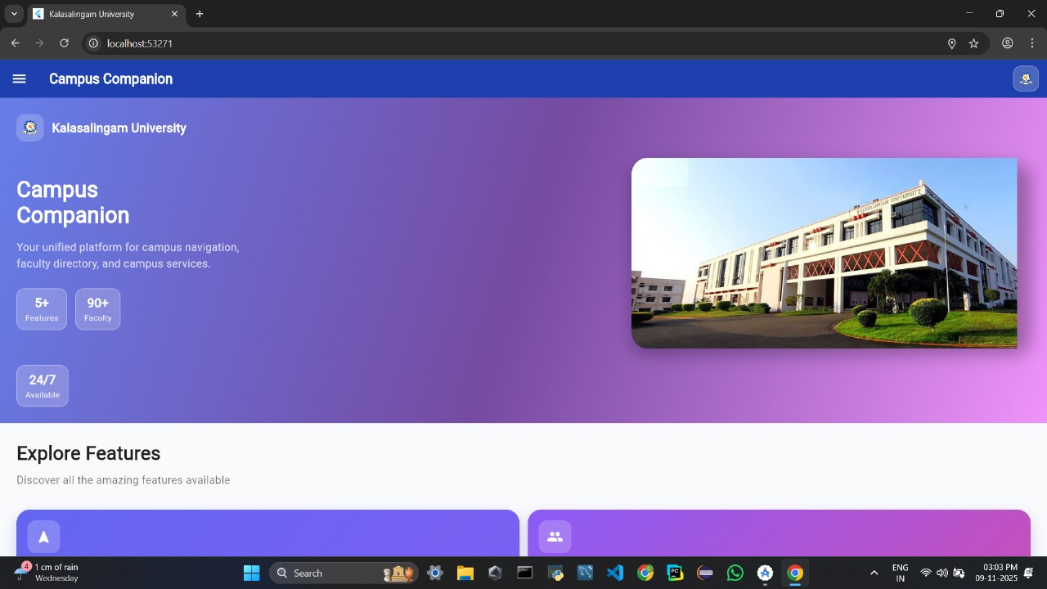

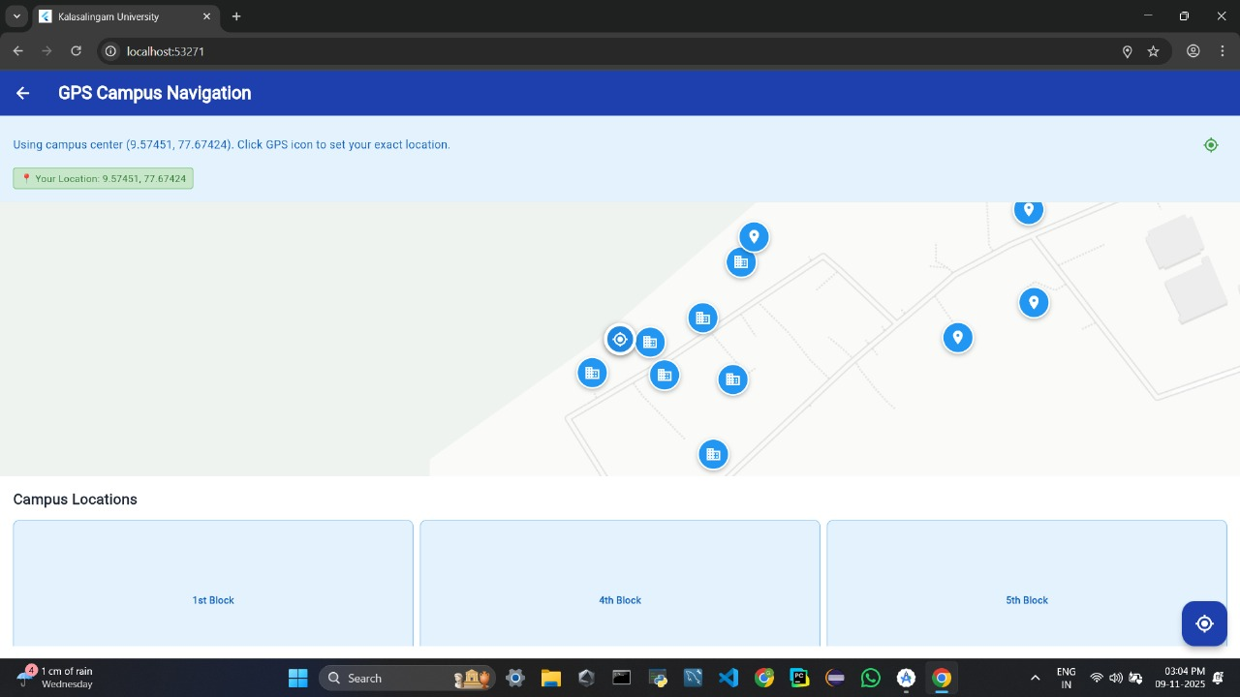
- GPS-based campus navigation map with multiple location markers for different buildings.
- current user location coordinates and option to set exact position.
- Includes campus blocks list (1st, 4th, 5th block) for quick navigation selection.
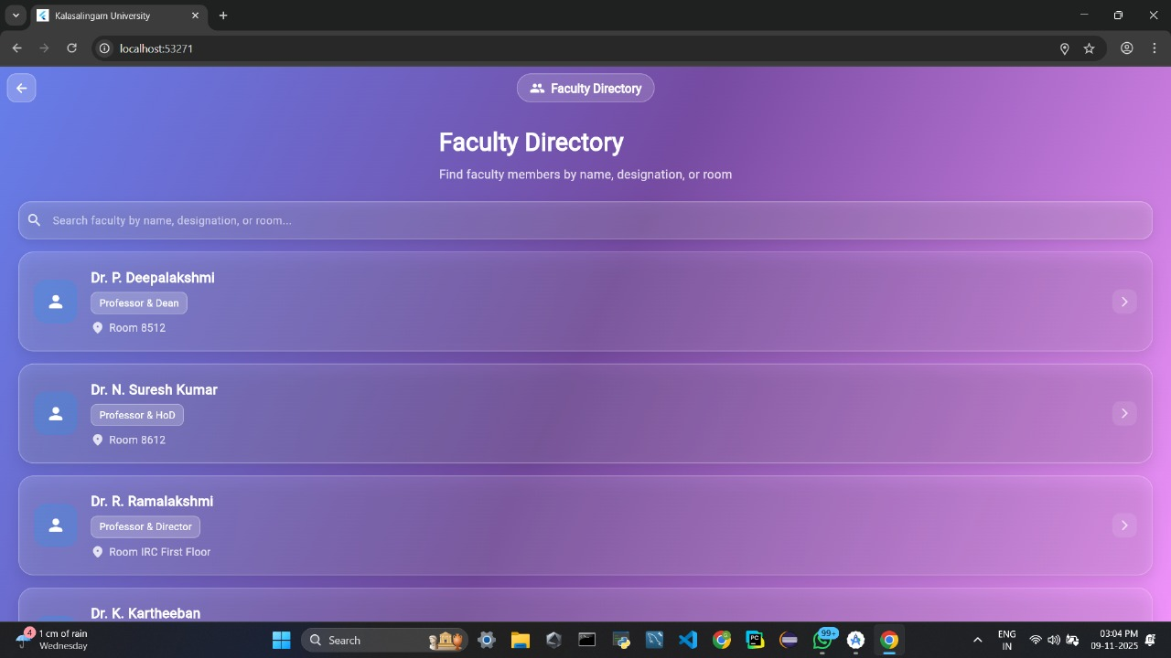

- Faculty Directory page with list of faculty members.
- Includes search bar to find faculty by name, designation, or room.
- faculty details like name, role, and room number

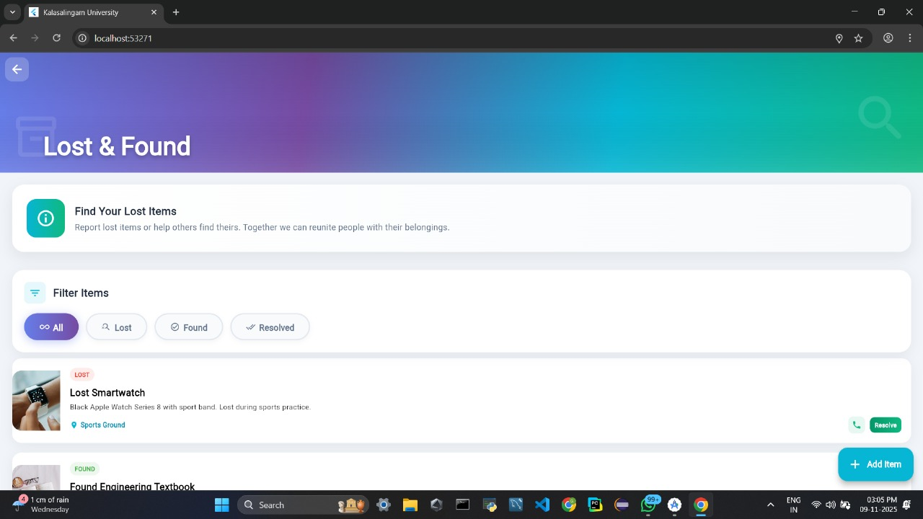
- Displays Lost & Found module for reporting and tracking lost items.
- Includes filter options (All, Lost, Found, Resolved) to organize items.
- Shows item details with description, location, and action buttons (Resolve/Add Item).
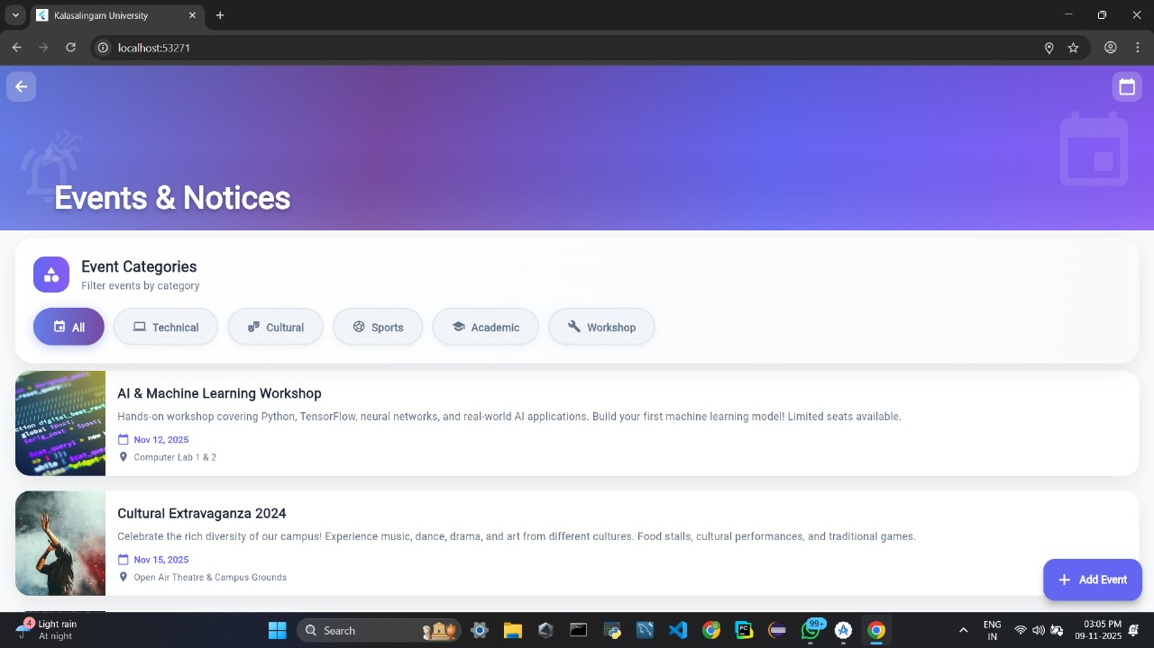
- Events & Notices section with upcoming campus events.
- category filters (Technical, Cultural, Sports, Academic, Workshop).
- Shows event details like title, date, location, and option to add events.
7.2 Evaluation Metrics
To comprehensively evaluate the performance of the Smart AI Proctor system, both quantitative and qualitative metrics were analyzed during controlled testing conditions. Detection accuracy was assessed across multiple components, including face detection, multi-face identification, and head pose estimation. The system demonstrated high face detection accuracy under normal lighting conditions, successfully identifying and tracking the candidate’s facial landmarks with precision. Multi-face detection was also accurate in clear environments, reliably flagging instances where more than one individual appeared within the camera frame. Head pose detection showed consistent results within predefined threshold margins, accurately identifying left, right, and downward movements without excessive deviation.
Response time was measured to determine system efficiency in real-time scenarios. The system achieved real-time processing with minimal latency, and average detection updates occurred within milliseconds, ensuring that suspicious behaviors were identified promptly without noticeable delay on the dashboard. The false positive rate was carefully monitored and found to be significantly reduced due to the implementation of temporal smoothing logic. Short or abrupt head movements did not immediately trigger violations, thereby enhancing fairness and reducing unnecessary alerts.
System stability was validated through continuous operation testing, during which the platform successfully ran for a two-hour session without crashes, freezing, or synchronization issues. Resource utilization metrics indicated moderate CPU usage during simultaneous audio and video processing, which is expected in a multi-threaded real-time system. Memory consumption remained stable throughout testing, with no evidence of memory leaks or performance degradation over time.
User feedback was also considered as a qualitative metric. Participants responded positively to the real-time visualization features, particularly the cheat probability graph, which provided transparency and clarity. Users appreciated the gradual suspicion logic rather than instant penalties, as it was perceived as more balanced and fair. Overall, the evaluation results confirmed that the system achieved stable, efficient, and reliable performance under controlled testing conditions, meeting both technical and user-centric expectations.

7.3 Comparison with Existing Systems
The Smart AI Proctor system was compared with existing online proctoring solutions.
Feature | Traditional Browser Lock | Webcam Recording | AI-Based Existing Systems | Smart AI Proctor
Browser Restriction | Yes | No | Yes | Optional
Face Detection | No | Manual Review | Yes | Yes
Head Pose Estimation | No | No | Limited | Yes
Audio Monitoring | No | No | Limited | Yes
Multi-Face Detection | No | No | Yes | Yes
Real-Time Probability Score | No | No | Rare | Yes
Temporal Smoothing | No | No | Limited | Yes
Automation Level | Low | Medium | High | High
False Positive Control | No | No | Limited | Improved
Advantages Over Existing Systems
- Multi-modal integration (vision + audio).
- Cheat aggregation engine with smoothing.
- Real-time graphical visualization.
- Reduced false positive rate.
- Open-source and cost-effective.

7.4 Challenges Faced
During the development and testing phases of the Smart AI Proctor system, multiple technical and operational challenges were encountered that required careful analysis and optimization. One of the primary challenges was lighting sensitivity, as poor or uneven lighting conditions significantly affected facial landmark detection accuracy. Since the vision module relies on precise detection of facial features, low-light environments sometimes resulted in delayed detection or minor inaccuracies in head pose estimation. Another challenge involved background noise, where unrelated environmental sounds such as fan noise, distant conversations, or sudden object movements occasionally triggered audio violation flags. This required refinement of threshold values and implementation of temporal filtering to minimize false detections.
Rapid head movements also posed a challenge during early testing stages. Natural and brief movements, such as quickly turning to adjust posture, initially caused false positives due to sudden fluctuations in yaw and pitch angles. This issue highlighted the need for smoothing logic and sustained-condition checks to distinguish between intentional suspicious behavior and normal physical movement. Additionally, CPU utilization became a concern when audio and video processing were executed simultaneously in a multi-threaded environment. Real-time facial landmark extraction and audio signal analysis increased computational load, particularly on low-end systems, requiring performance optimization strategies such as frame resolution reduction and processing loop improvements.
Beyond technical aspects, privacy concerns emerged as an important challenge. Continuous webcam and microphone monitoring raised ethical considerations among users, especially regarding data storage, surveillance transparency, and consent. Addressing these concerns required clear communication about data usage policies, secure logging mechanisms, and responsible system design. Overall, these challenges contributed to valuable system improvements and helped strengthen the reliability, efficiency, and ethical compliance of the Smart AI Proctor solution.

7.5 Solutions and Improvements
To address the challenges identified during development and testing, several targeted improvements were implemented to enhance the accuracy, stability, and reliability of the Smart AI Proctor system. One of the major enhancements was the implementation of a temporal smoothing algorithm within the aggregation module. Instead of triggering immediate violations for short suspicious events, the system now increases suspicion gradually during confirmed violations and reduces it slowly when normal behavior resumes. This significantly reduced false positives and created a more balanced evaluation mechanism. Threshold optimization was another key improvement, where yaw and pitch angle limits, along with audio RMS thresholds, were carefully fine-tuned based on testing observations to improve detection precision under varied real-world conditions. Additionally, a sustained audio validation mechanism was introduced, ensuring that audio violations are triggered only after multiple consecutive suspicious cycles rather than isolated noise spikes. This refinement helped eliminate unnecessary alerts caused by brief environmental disturbances.
To improve system performance, especially on low-end devices, frame optimization techniques were applied by reducing video resolution and streamlining the processing loop. This reduced CPU load while maintaining reliable detection accuracy. From a security and ethical standpoint, secure logging mechanisms were proposed, including encryption of violation records and controlled administrative access to ensure data protection and privacy compliance.
Looking ahead, several future enhancements can further strengthen the system’s capabilities. Integration of object detection models such as YOLO could enable detection of prohibited objects like mobile phones during examinations. Advanced deep learning models may be incorporated for more sophisticated behavioral analysis, enabling the system to recognize complex suspicious patterns beyond simple head movements and sound detection. The adoption of federated learning techniques could improve privacy preservation by allowing decentralized model training without transferring sensitive user data to central servers. Blockchain technology could also be integrated to create tamper-proof examination logs, ensuring transparency and data integrity. Furthermore, the development of adaptive AI models capable of dynamically adjusting detection thresholds based on environmental conditions and user behavior would enhance overall robustness and fairness. Together, these improvements and future enhancements position the Smart AI Proctor system as a scalable, intelligent, and secure solution for next-generation remote examination monitoring.

CONCLUSION & FUTURE SCOPE
Conclusion
The increasing size and complexity of modern educational campuses have created a growing need for smart, digital solutions that can simplify navigation, improve accessibility, and enhance overall campus experience. Traditional methods of finding locations, accessing faculty information, or tracking campus events are often time-consuming, inefficient, and confusing, especially for new students and visitors. To address these challenges, this project successfully designed and implemented the Campus Companion System, a unified digital platform that integrates multiple campus services into a single, user-friendly interface.
The developed system provides an intelligent solution by combining GPS-based navigation, faculty directory management, event tracking, and lost-and-found services within one platform. The GPS Campus Navigation module allows users to locate buildings and navigate efficiently using real-time location tracking and map-based visualization. The Faculty Directory module simplifies communication by enabling users to search faculty members based on name, designation, or room number. Additionally, the Events & Notices module ensures that users stay updated with ongoing and upcoming campus activities, while the Lost & Found module helps in reporting and retrieving misplaced items, improving campus coordination and community support The system was implemented using modern web technologies, ensuring a responsive and visually appealing user interface. Features such as search functionality, category filtering, real-time updates, and intuitive design significantly enhance usability. The integration of multiple modules into a single platform reduces dependency on manual assistance and improves efficiency in daily campus operations.
Testing and evaluation results confirmed that the system performs reliably under various scenarios, providing accurate navigation, fast data retrieval, and smooth user interaction. The platform demonstrated stability, scalability, and ease of use, making it suitable for deployment in real-world campus environments. Overall, the Campus Companion system successfully achieves its objective of creating a centralized, smart, and accessible campus management solution, thereby improving user experience and operational efficiency.
Future Scope
Although the Campus Companion system provides a comprehensive solution for campus navigation and services, several enhancements can be implemented to further improve its functionality, scalability, and user experience. One of the key future improvements includes the integration of advanced indoor navigation systems using technologies such as Bluetooth beacons or Wi-Fi positioning, which would allow precise navigation داخل buildings where GPS signals are weak or unavailable Another important enhancement is the development of a mobile application for Android and iOS platforms. This would increase accessibility and allow users to access campus services on the go with features such as push notifications for events, alerts for lost items, and real-time navigation updates. Additionally, integrating AI-based chatbots can provide instant assistance to users by answering queries related to locations, faculty details, or campus services.
The system can also be expanded by incorporating real-time data integration, such as live event updates, classroom schedules, and administrative announcements directly from institutional databases. Adding user authentication and role-based access control would enhance security and allow personalized features for students, faculty, and administrators.
Further improvements may include the use of data analytics to track user behavior and optimize frequently accessed services, thereby improving system efficiency. Integration with IoT-based smart campus infrastructure can enable features like smart parking, energy management, and crowd monitoring. Additionally, implementing cloud-based deployment would ensure better scalability, reliability, and performance for handling large numbers of users simultaneously.
From a usability perspective, multilingual support can be added to make the system accessible to a diverse user base. Enhanced UI/UX design improvements and accessibility features for differently-abled users can further broaden the system’s impact.

REFERENCES
[1] OpenStreetMap, “OpenStreetMap Data for Campus Navigation Systems,” 2024. [Online]. Available: https://www.openstreetmap.org/
[2] Leaflet.js Documentation, “Interactive Maps for Web Applications,” 2024. [Online]. Available: https://leafletjs.com/
[3] Google Maps Platform, “Location Services and GPS-Based Navigation,” 2024. [Online]. Available: https://developers.google.com/maps
[4] React.js Documentation, “Building User Interfaces for Web Applications,” 2024. [Online]. Available: https://react.dev/
[5] Bootstrap Documentation, “Responsive Web Design and UI Components,” 2024. [Online]. Available: https://getbootstrap.com/
[6] Node.js Documentation, “Backend Development and Server-Side Programming,” 2024. [Online]. Available: https://nodejs.org/
[7] Express.js Documentation, “Web Application Framework for API Development,” 2024. [Online]. Available: https://expressjs.com/
[8] MongoDB Documentation, “Database Management for Web Applications,” 2024. [Online]. Available: https://www.mongodb.com/
[9] MDN Web Docs, “HTML, CSS, and JavaScript Reference Guide,” 2024. [Online]. Available: https://developer.mozilla.org/
[10] Stack Overflow, “Programming Support and Debugging Resources,” 2024. [Online]. Available: https://stackoverflow.com/
[11] “Design and Implementation of Smart Campus Navigation Systems,” International Journal of Computer Applications, 2022.
[12] “Web-Based Campus Management and Navigation System Using GIS,” IEEE Xplore Digital Library, 2023. [Online]. Available: https://ieeexplore.ieee.org


INTERNAL QUALITY ASSURANCE CELL
PROJECT AUDIT REPORT

This is to certify that the project work entitled “Smart AI Proctor: AI-Based Online Exam Proctoring System” categorized as an internal project done by Vutukuri Bhuvan Naga Venkata Sai Kiran, Galla Sri Harsha, Sanivarapu Anjan Kumar Reddy, Govindu Karthik of the Department of Computer Science and Engineering, under the guidance of Mrs. S. Reshni during the Even semester of the academic year 2023 - 2024 are as per the quality guidelines specified by IQAC.

Quality Grade

Deputy Dean (IQAC)

Administrative Quality Assurance Dean (IQAC)
